Project Design Phase
Solution Architecture

Date | 11 September 2026
Project Name | Laptop Request Management System
Maximum Marks | 4 Marks

Solution Architecture:
Solution architecture is a complex process – with many sub-processes – that bridges the gap between business problems and technology solutions. Its goals are to:
- Find the best tech solution to solve existing business problems.
- Describe the structure, characteristics, behavior, and other aspects of the software to project stakeholders.
- Define features, development phases, and solution requirements.
- Provide specifications according to which the solution is defined, managed, and delivered.

Example - Solution Architecture Diagram:

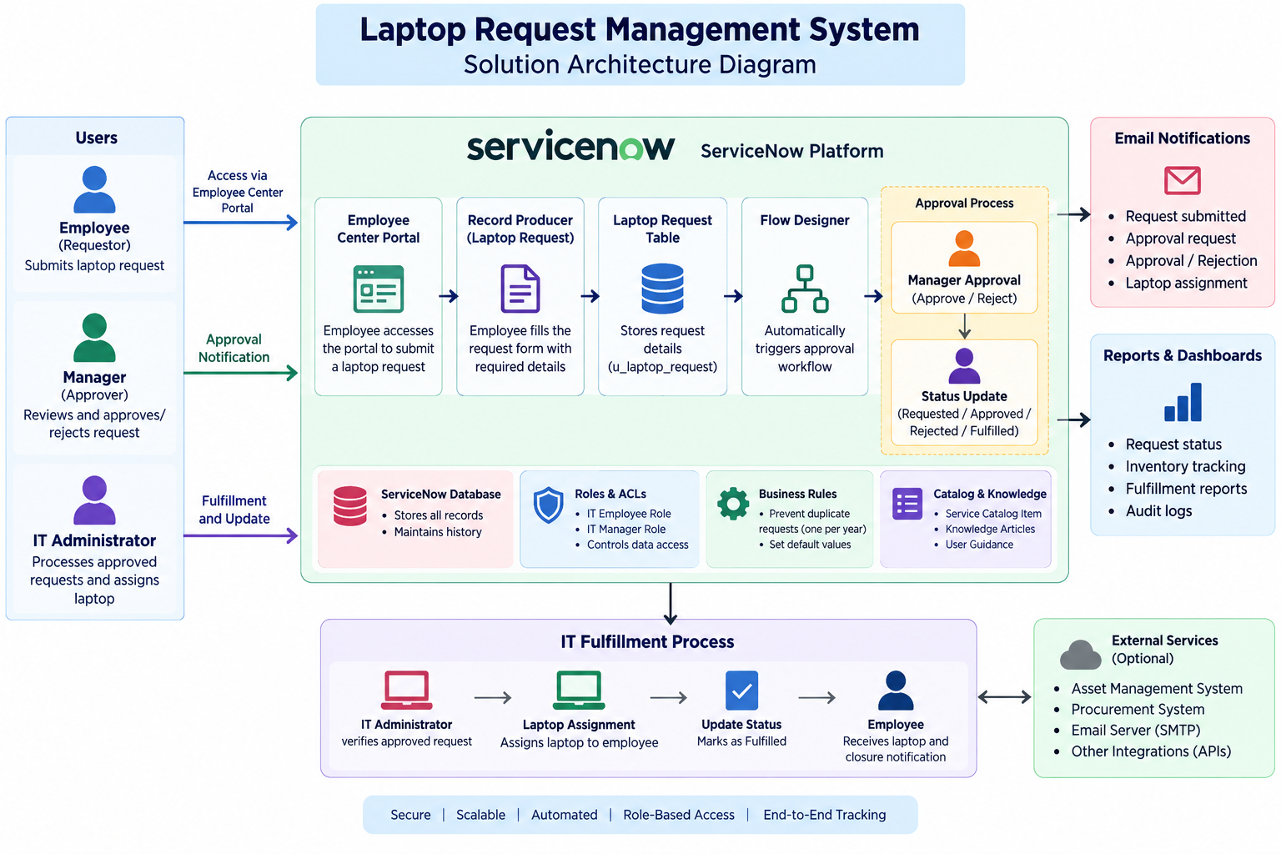
Figure 1: Solution Architecture Diagram – Laptop Request Management System
Reference:
ServiceNow Documentation
ServiceNow Flow Designer
ServiceNow Access Control Lists (ACLs)

